

JAVA PROJECT REPORT ON
Appointment Scheduling and Reminder System

Submitted by
PREETHIKA V
25BCS246

Under the Guidance of
DHARANEESH Technical Trainer
Technical Department, KG College of Arts and Science

Academic Year: 2025 – 2026
APRIL 2026
Semester: II

DECLARATION
I hereby declare that the project entitled “Appointment Scheduling and Reminder System” submitted in partial fulfillment of the requirements for the course Java Programming is a record of my original work carried out under the guidance of Dharaneesh , Technical Trainer, Technical Department, KG College of Arts and Science.
I further declare that this project has not been submitted previously, either in part or in full, for the award of any degree, diploma, or other similar title, at this or any other institution.

April 2026
Coimbatore

PREETHIKA V
(Your Name)

CERTIFICATE
This is to certify that the project entitled “Appointment Scheduling and Reminder System” is a bona fide work carried out by PREETHIKA V, B.SC.Computer science, KG College of Arts and Science , in partial fulfillment of the requirements for the course java programming.
This project has been completed under my supervision and guidance during the academic period April 2026.

Place: Coimbatore
Date:10.04.2026

Submitted for the Viva-Voce Examination held on 10.04.2026

Guide: Head of the Department
(Technical Trainer, KGCAS) (Technical Head, KGCAS)
DHARANEESH BOOPALAN

TABLE OF CONTENTS
S. No. | Topics | Page. No.
1 | Introduction
1.1 | Objective
1.2 | Overview
1.3 | Features
2 | Program Analysis
2.1 | Problem Definition
2.2 | Project Overview
2.3 | Scopes and Limitations
3 | System Design
3.1 | Modules
4 | Methodology
4.1 | Problem Analysis
4.2 | System Design
4.3 | Program Development
4.4 | Testing and Validation
4.5 | Result and Documentation
4.6 | Algorithm
4.7 | Flowchart
5 | Source Code
6 | Input and Output Screens
7 | Discussion and Conclusion
7.1 | Discussion
7.2 | Conclusion
8 | References

ABSTRACT
The Appointment Scheduling and Reminder System is a Java-based application designed to manage and organize appointments efficiently. In many clinics, offices, and service centers, appointments are often handled manually, which can lead to scheduling conflicts, missed appointments, and poor time management.
This system provides a digital solution that allows users to schedule, view, update, and delete appointments easily. It also includes a reminder feature that notifies users about upcoming appointments, reducing the chances of forgetting important meetings.
The application is developed using Core Java concepts such as classes, objects, loops, and conditional statements. It can be implemented as a console-based system or enhanced using Java Swing for a graphical interface.
The main objective of this project is to improve scheduling efficiency, reduce manual errors, and ensure better time management through automated reminders.

- INTRODUCTION
In today’s fast-paced world, managing appointments manually is time-consuming and prone to errors. Many small clinics, offices, and service providers still rely on paper-based systems or basic tools, which can result in double bookings, missed appointments, and poor record maintenance.
With the advancement of technology, automated appointment systems have become essential. These systems help users schedule appointments, manage time efficiently, and receive reminders for upcoming events.
The Appointment Scheduling and Reminder System is designed to provide a simple and effective solution for managing appointments. The system allows users to add, update, delete, and view appointments. It also generates reminders before scheduled times.
This project is developed using Core Java programming concepts and demonstrates how real-world scheduling problems can be solved using software applications.

1.1 Objective
The main objective of the Appointment Scheduling and Reminder System is to develop a Java-based application that automates appointment management.
Specific objectives include:
- To create a system for scheduling appointments
- To manage appointment details efficiently
- To provide reminders for upcoming appointments
- To reduce scheduling conflicts and missed appointments
- To demonstrate Core Java programming concepts
- To provide a user-friendly interface

1.2 Overview
The Appointment Scheduling and Reminder System is a menu-driven Java application. It allows users to enter appointment details such as date, time, and description.
The system stores appointment information and displays reminders before the scheduled time. Users can also update or delete appointments when required.
This system helps in organizing daily schedules and ensures that important appointments are not missed.

1.3 Features
- Appointment Booking – Add new appointments with date and time

- View Appointments – Display all scheduled appointments

- Update Appointments – Modify existing appointment details

- Delete Appointments – Remove unwanted appointments

- Reminder System – Notify users of upcoming appointments

- User-Friendly Interface – Easy menu-driven system

- Efficient Time Management – Helps organize schedules

2 . PROGRAM ANALYSIS
Program analysis is an important phase in software development where the problem is studied in detail and the requirements of the system are identified. This stage helps in understanding how the system should work and what features are required to solve the problem efficiently.
The analysis phase focuses on identifying the current issues in the existing system and proposing a computerized solution that improves efficiency and accuracy.
2.1 Problem Definition
Manual appointment scheduling systems have several issues:
- Risk of double booking
- Missed appointments
- Poor record maintenance
- Time-consuming process
- Lack of reminders
These problems highlight the need for an automated appointment scheduling system.

2.2 Project Overview
The system provides functionalities such as:
- Adding new appointments
- Viewing appointment lists
- Editing and deleting appointments
- Generating reminders
It simplifies scheduling and ensures better time management.

2.3 Scopes and Limitation

Scope
- Clinics and hospitals
- Offices and meeting scheduling
- Personal appointment management
- Service-based businesses

Limitations
- No real-time notifications (in basic version)
- Limited storage (if no database used)
- Console-based interface (basic version)

3.SYSTEM DESIGN
System design is the stage where the structure and components of the system are planned before the actual implementation. In this phase, the system is divided into different modules, and the workflow of the application is defined. Proper system design helps in organizing the program efficiently and makes development easier.
In the Appointment Scheduling and Reminder System, system design focuses on creating a structured and organized solution to manage appointments efficiently. The system is designed as a menu-driven application where users can add, view, update, and delete appointments, as well as receive reminders for upcoming events.
The design ensures that the system is simple, user-friendly, and capable of handling appointment data effectively. It divides the application into multiple modules, each responsible for a specific function such as appointment entry, management, reminder generation, and data storage.
The workflow of the system begins with displaying a menu to the user. Based on the selected option, the system performs actions like scheduling a new appointment, displaying existing appointments, modifying details, or checking reminders.

3.1 Modules
1. Appointment Entry Module
- Accepts user input for appointment details
- Stores date, time, and description
2. Appointment Management Module
- Displays all appointments
- Allows updating and deleting
3. Reminder Module
- Checks upcoming appointments
- Displays reminder messages
4. Storage Module
- Stores appointment data temporarily (arrays or lists)
5. Exit Module
- Safely exits the program

4.METHODOLOGY
Methodology describes the process followed to develop the project. It explains the steps taken from understanding the problem to designing, implementing, testing, and documenting the system.
In the Appointment Scheduling and Reminder System, the methodology outlines how the system is developed from understanding the problem to delivering the final application. It ensures that each stage of development is carried out in an organized manner.
The development process includes the following stages:
• Problem Analysis• System Design• Program Development• Testing and Validation• Result and Documentation
4.1 Problem Analysis
Identified issues in manual scheduling such as missed appointments and poor organization.
4.2 System Design
System divided into modules for better structure and functionality.
4.3 Program Development
Implemented using Java concepts:
- Classes and objects
- Loops and conditions
- Arrays or ArrayList
4.4 Testing and Validation
Test Cases:
Test Case | Expected Result
Add appointment | Stored correctly
View appointments | Display list
Update appointment | Changes applied
Delete appointment | Removed successfully
Reminder check | Correct alert shown

4.5 Result and Documentation
The system successfully manages appointments and provides reminders. Results are shown through program outputs and screenshots.
4.6 Algorithm
- Start the program
- Display menu options
- Choose operation (Add/View/Update/Delete)
- Enter appointment details
- Store or modify data
- Check for upcoming appointments
- Display reminders
- Repeat until exit
- End program
4.7 Flowchart
Start
↓
Display Menu
↓
Select Option
↓
Enter/View/Update/Delete Appointment
↓
Check Reminder
↓
Display Output
↓
End

5.SOURCE CODE

the Input of the Code for your Appointment Scheduling and Reminder System
INPUT OF THE PROGRAM
The program takes input from the user in three ways:
- Menu Choice
  - User selects an option (Add, View, Delete, Exit)
- Appointment Details
  - User enters appointment information (e.g., date, time, purpose)
- Appointment Number
  - User enters the number to delete a specific appointment

6.INPUT AND OUTPUT SCREENS

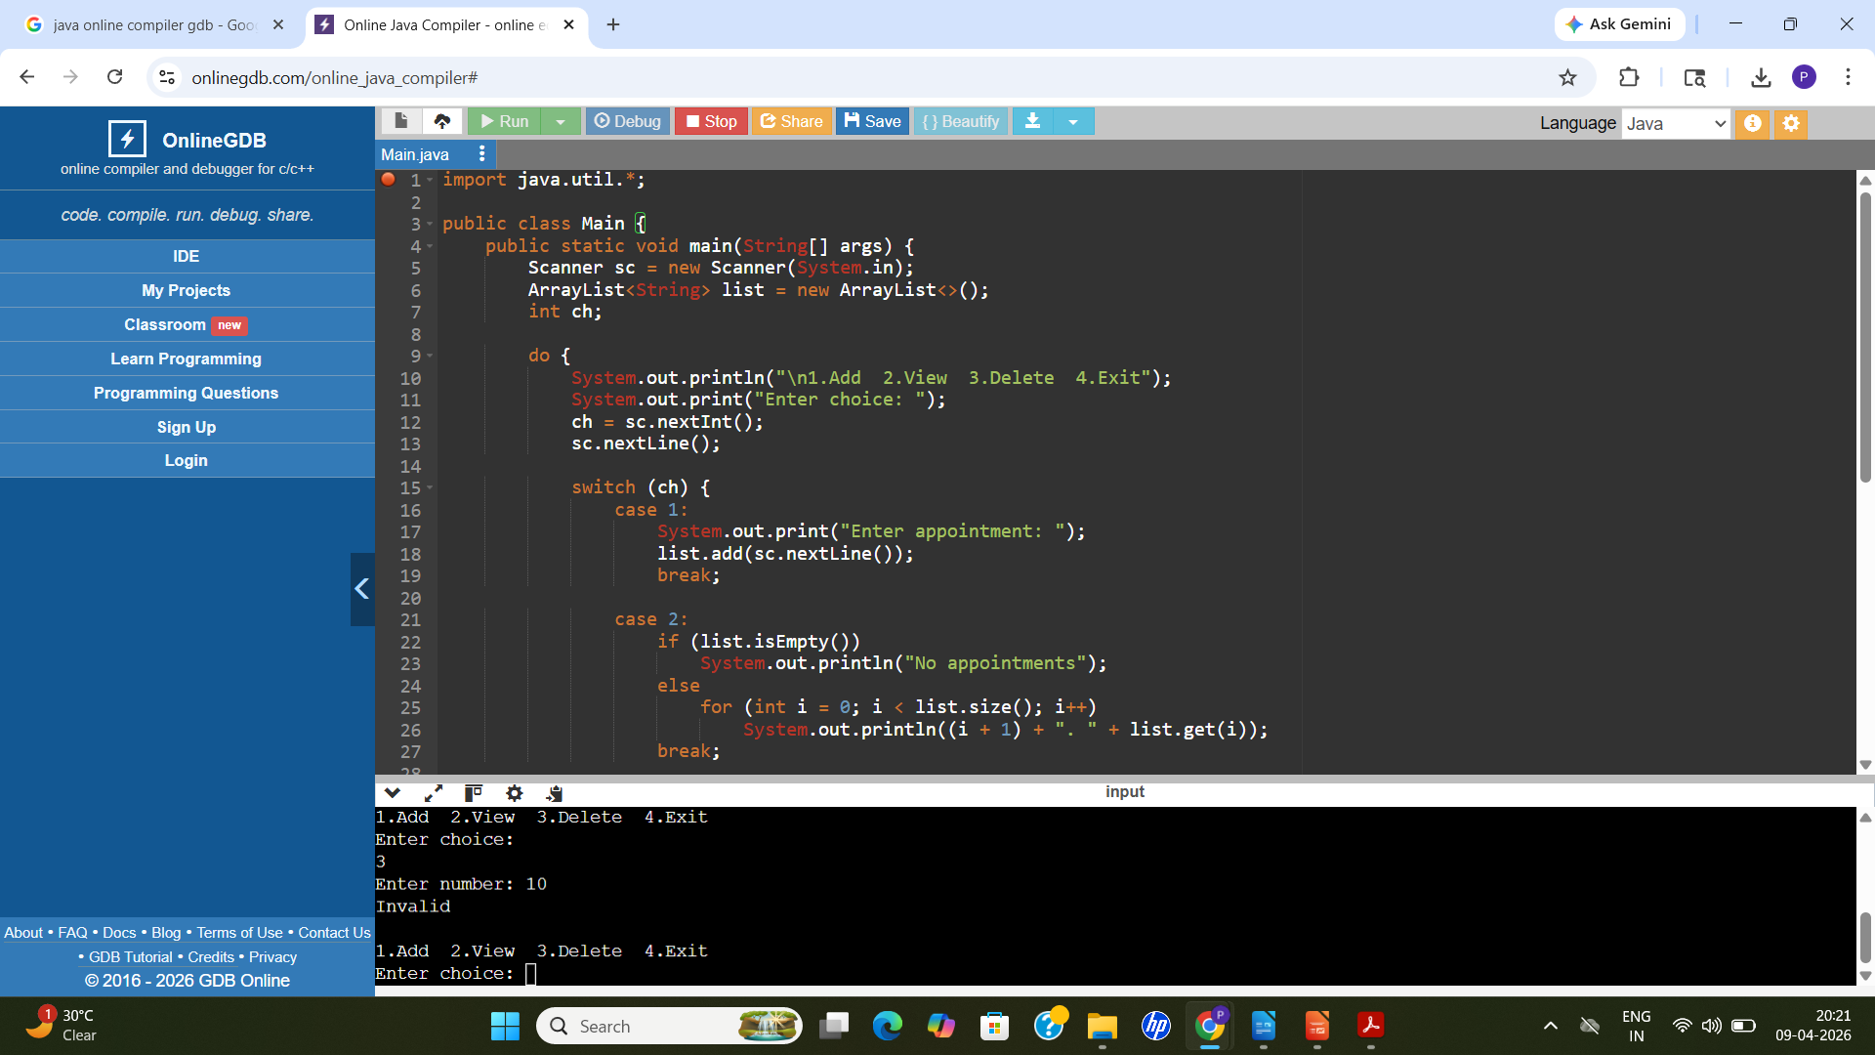

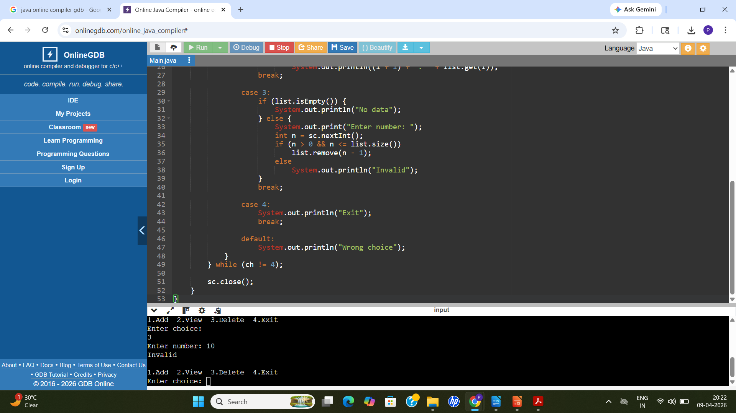

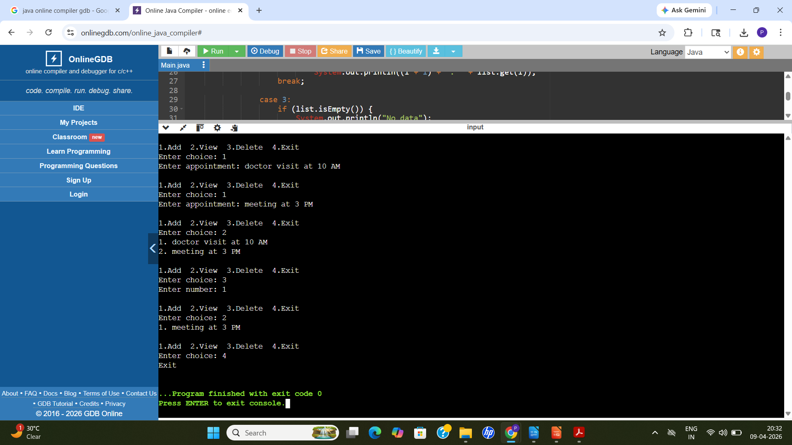

7.DISCUSSION & CONCLUSION
7.1 Discussion
The Appointment Scheduling and Reminder System was developed to automate the process of managing appointments. It replaces manual methods that often cause missed appointments, errors, and poor record keeping. The system uses Core Java concepts like ArrayList, loops, and conditional statements to perform operations such as adding, viewing, and deleting appointments.
The program was tested with different inputs and worked correctly in all cases. It is simple, user-friendly, and helps in better time management. However, it has some limitations such as lack of permanent data storage and advanced reminder features. These can be improved in future versions.

7.2 Conclusion
The system successfully achieves its goal of simplifying appointment management. It reduces manual effort and improves efficiency. The project also helps in understanding basic Java programming concepts.
In future, the system can be enhanced with database support, GUI, and real-time reminders. Overall, it is a useful and practical application.

8.REFERENCES

The following resources were used during the development of this project:
Books
Books:
- Herbert Schildt – Java: The Complete Reference
Websites:
- https://www.oracle.com/java
- https://www.geeksforgeeks.org
- https://www.w3schools.com
- https://www.javatpoint.com

